Department of Civil and Environmental Engineering

The Hong Kong University of Science and Technology

**CIVL 1100**

**Discovering Civil and Environmental Engineering**



**Laboratory Report on Structural Engineering Experiments**

**Fall/Spring 202?**

Group :

Date of experiment :

Group members :

Date of submission :

**Test 1 – Three Pinned Arch Experiment (STR9)**

* 1. (i) Plot a graph of ‘*Experimental horizontal reaction*’ (in N) as the vertical axis versus ‘*Distance from left*’ as the horizontal axis (in mm). Label the axes clearly, with an appropriate title.

(5 marks)

(ii) What is the relationship between the applied load and the corresponding horizontal reaction? In what position you would place a point load to maximize the horizontal reaction? Comment on the results.

(3 marks)

(You may use Excel to plot the graph, or you can plot it on a graph paper.)

* 1. (i) What are the support conditions of the three-pinned arch?

(1 mark)

(ii) Develop a simplified structural model of the arch for analysis (including the arch structure, the supports, and any other necessary details of the experimental set-up you can find). Label all the dimensions on the diagram.

(3 marks)

* 1. (i) The three-pinned arch structure is separated from supports A and B. Complete the free-body diagram of the whole arch. (Fig. 1.3(a))

(4 marks)

A

B

C

*W*

*x*

Fig. 1.3(a)

(ii) The arch is further separated at pinned connection C. Complete the free-body diagrams of the two halves. (Fig. 1.3(b))

(8 marks)

A

B

C

*W*

*x*

Fig. 1.3(b)

1.4 (i) Refer to your completed free-body diagram in Fig. 1.3 (a), write the moment equilibrium equation of the whole arch by taking moment at support B;

(1 mark)

(ii) Refer to Fig. 1.3(b), consider the left-hand half of the arch bridge AC, write the moment equilibrium equation at pinned connection C;

(1 mark)

(iii) From the results of (a) and (b), verify.

(*HA* is the horizontal reaction at support A)

(3 marks)

* 1. Compare the experimental data with the theoretical values obtained in the virtual experiment. Comment on the two sets of data. Discuss the possible experimental errors.

(3 marks)

**Test 2 – Redundant Truss Experiment (STR17)**

**2.1. Statically Determinate Structure Test**

* + 1. Indicate the purpose of measuring the initial reading in strain gauges (i.e. ‘Measured strain’ when Force = 0 N) before applying loading.

(2 marks)

2.1.2 Identify the state of the member force in every member, compression, tension or a zero-force member, using the measured data.

(7 marks)

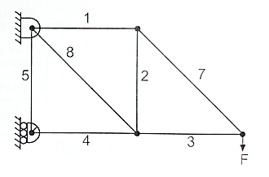 Fig. 2.1

2.1.3 (i) Plot TWO graphs of ‘*Measured* *Strain*’ versus ‘*Applied Load’* (‘*Measured* *Strain*’ is the y-axis and ‘*Applied Load’ is the x-axis*) **for members 3 and 7** (refer to Fig. 2.1) separately. Label the axes clearly, with an appropriate title.

(8 marks, 4 marks for each graph)

(ii) What is the relationship between member strain and external load?

(1 mark)

(iii) From the two graphs, what can you say about members 3 and 7?

(2 marks)

(You may use Excel to plot the graphs, or you can plot it on a graph paper.)

*[Note.*

*If the strain data from member 3 or 7 are not available, you can use the data from another member under the same tension or compression.]*

* + 1. (i) Plot a graph of ‘*Measured* *Displacement*’ versus ‘*Applied Load’*. On the same graph, also plot the ‘*Theoretical* *Displacement*’ versus ‘*Applied Load’* as a comparison. (Please make sure the signs of displacement are correct.)

(7 marks)

(ii) What is the physical meaning of this graph, or what is the physical law behind? What does the slope of the graph tell you?

(2 marks)

(You may use Excel to plot the graph, or you can plot it on a graph paper.)

* + 1. Compare the experimental data with the theoretical results obtained in virtual experiment. Comment on the two sets of data.

(3 marks)

* + 1. Explain the reading of **member 5**.

1. marks)
   * 1. (i) Complete the free-body diagram for the statically determinate cantilever truss shown below.

(3 marks)

(ii) Calculate the reactions if the external force F = 50 N. Show your step-by-step calculations.

(5 marks)

50 N

* + 1. (i) Complete the following force diagrams.

(6 marks)

(ii) Determine **ALL** the member forces (6 members) when *F* = 50 N. Please show your calculation steps clearly.

(9 marks)

50 *N*

7

3

7

1

2

2

4

3

8

* 1. **Statically Indeterminate Structure Test**

2.2.1 (i) Compare the slope of the displacement-load graphs in the first experiment and this experiment (not necessarily to plot the graphs).

(1 mark)

(ii) Compare the overall stiffness of the two trusses.

(1 mark)

* + 1. Identify the major differences after member 6 is added in the indeterminate truss.

(2 marks)

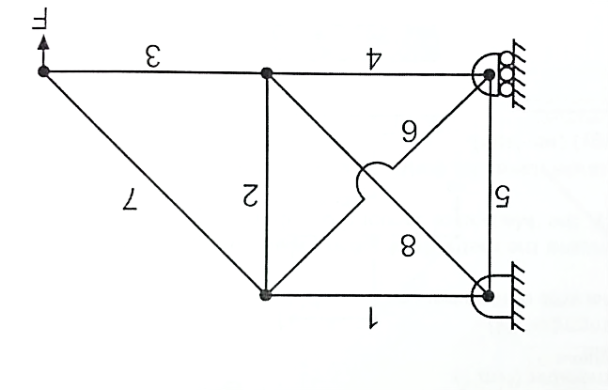

* + 1. According to the comparisons presented in 2.2.1 to 2.2.2, what do you think about the safety and economy of the two different structures? What are the possible pros and cons of adopting an indeterminate truss design? (Open-ended question)

(4 marks)

(Please attach **ONE** complete set of lab record sheets at the end of this report.)

~ End of the report ~